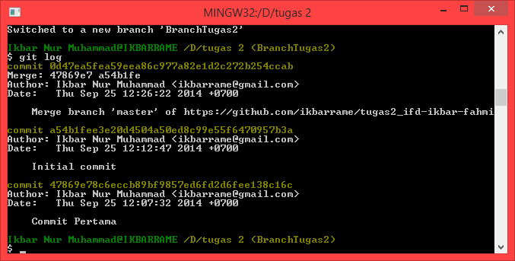Git Project Manager (Ikbar Nur Muhammad)

Git Log Collaborator (Fahmi Ahmad Jauhary)

